**Manuals for ‘Manage Jaslok Times’**

**Brief of the ‘Manage jaslok times’ –** This is the page where we manage jaslok times content.

**1. How to manage jaslok times content-.**

Steps:

1. Login to the site and go to ‘Masters’ tab and click on ‘Manage jaslok times content’.
2. On ‘Manage jaslok times’ page the listing of jaslok times and ‘Add jaslok times’ button will display.
3. On this page we can edit and delete the existing records.
4. Click on ‘Add jaslok times’ button for add new records.
5. The added new Doctor’ will display jaslok times page (http://jaslokhospital.net/jasloktimes).

1.

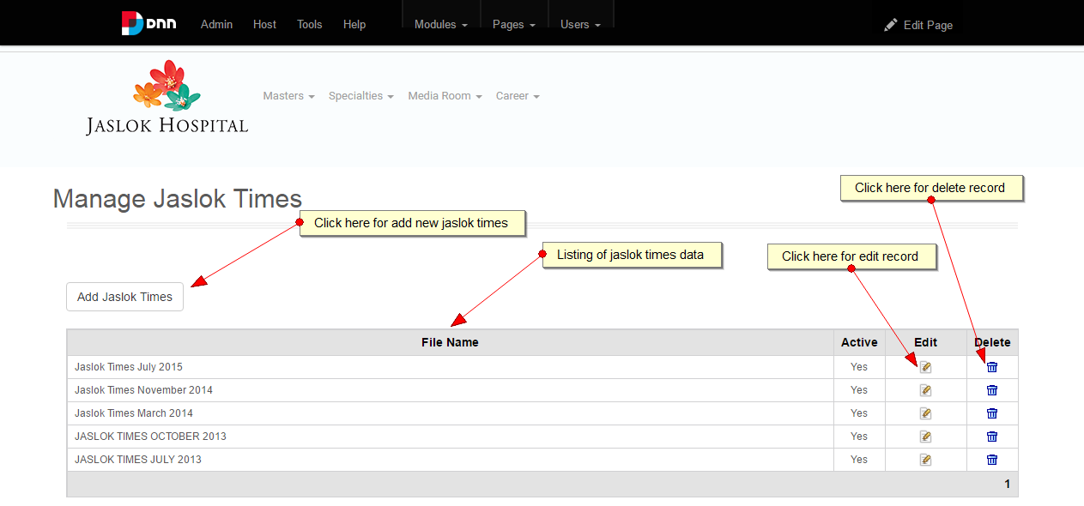

2.

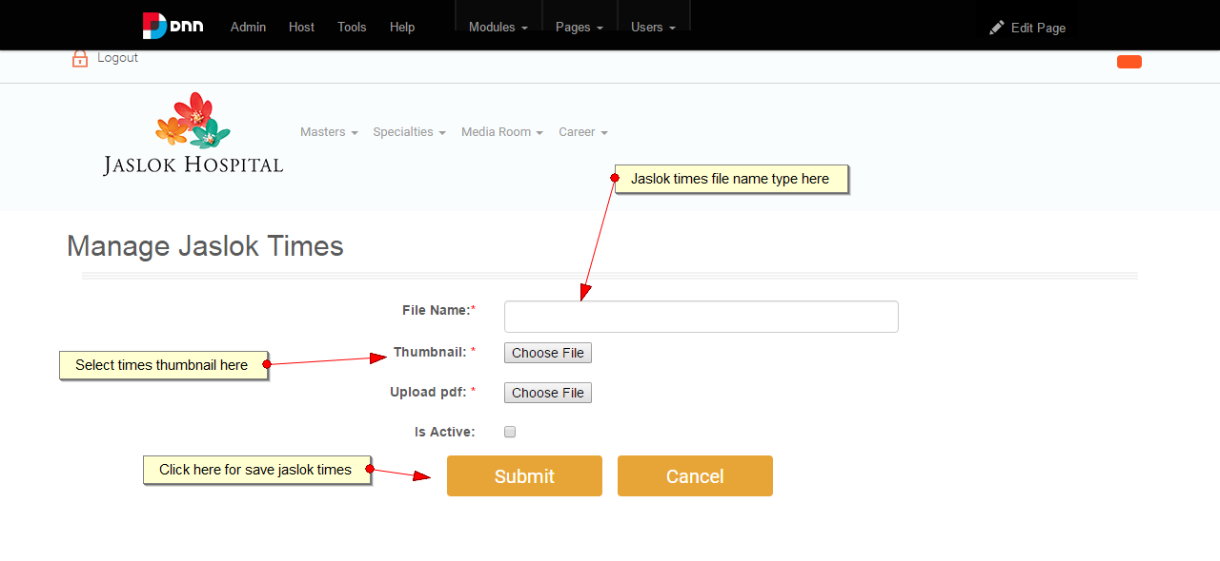

3.

